**Game mechanic proposal – template**

**Student name and surname**: Ho Hei Tam

**Student number**: 10565565

**Name of the game**: Flying Bug

**Target platform**: Windows

**Controls**: Keyboard only

**Tools**:

Trello – Project Management

Unity – Game Engine and Coding

GitHub - Repo

Adobe Photoshop – Editing Materials and Textures

**Story**:

Our little buggy used to have a very sweet home in its hive, where it lived happily without worrying anything. However, one day, it was destroyed by malicious predator. Little buggy now must seek for another place to continue its live. It is going to be a treacherous way for the buggy. Would it finally find itself another place it can call a home to live on?

**References/Inspiration**:

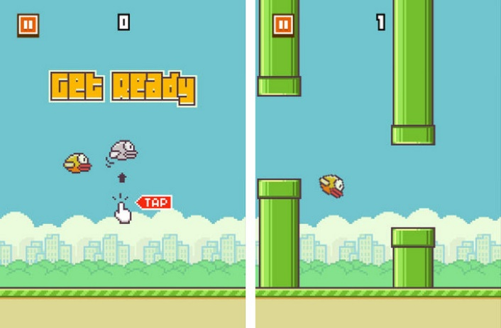The game mechanics are slightly similar to Flappy Bird. In Flappy Bird, player needs to constantly tap the screen in order to keep the bird flying otherwise it falls. Every tap is a boost. However, my idea is different. The game will be in 3D which requires the player to steer left and right, rather than just up and down only. Player will not need to rapidly hit a screen (or key) to increase the character’s height as there will be a stamina bar which the player can hold a key to keep raising as long as they have energy in it

**Aim**:

I am trying to make the game control similar to flappy bird but in 3D. Besides, player needs to control tilting left and right, unlike up and down only in flappy bird If the player does not fly, the bird will start to fall. If it reaches down to a certain point, the game will end. As mentioned above, the player requires stamina to fly. By only using the stamina provided at the starting point will not be enough to bring the bird to the end. During the game, there will be checkpoints or ‘power up’. Checkpoints basically a platform where player can take a rest for a while and continue the adventure, ‘power up’ can slightly restore the stamina. Besides, obstacles like other birds and props will get in the player’s way. The player must manage to dodge these obstacles while not to run out of stamina. This is going to be the player’s biggest challenge

